Game Design Document for:

Origin Infection/

EBOLA: The Origins

The Funnest Edutainment Game on Roblox

Copyright © GET Pte. Ltd.

Written by

Teo Yi Kai

Yeo En Yew, Benjamin

Perry Yap Wai Kit

Version # 1.00

Current Date

**Table of Contents**

**1** **Design History**

1.1 Version 1.10

1.2 Version 2.00

1.3 Version 2.10

**2** **Game Overview**

2.1 Introduction/Summary

2.2 Common Questions

2.2.1 What is the game?

2.2.2 Why create this game?

2.2.3 Where does the game take place?

2.2.4 What do I control?

2.2.5 What is the main focus?

2.2.6 What's different?

**3** **Feature Set**

3.1 General Features

3.2 Multi-Player Features

3.3 Game-Play

**4** **The Game World**

4.1 Overview

4.2 Key World Features

4.3 The Physical World

4.4 Graphics

4.4.1 Overview

4.4.2 2D/3D Rendering

4.4.3 Art Style

4.4.4 Animation

4.4.5 Camera

4.4.6 Lighting Style

4.5 Other Technical Features

4.5.1 Sound

4.5.2 Physics

4.5.3 Collision Detection

4.5.4 A.I.

4.6 Game Engine

4.6.1 Overview / Requirements

4.6.2 Engine Short-list

4.6.3 Chosen Engine

**5** **The World Layout**

5.1 Overview

5.2 World Layout Details

**6** **Game Characters**

6.1 Overview

6.2 Creating a Character

6.3 Hero/Heroes

6.4 Friends

6.5 Enemies & Monsters

6.6 Bystanders

**7** **User Interface**

7.1 Overview

7.2 In-Game Control System

7.3 Front-end and Menus

**8** **Weapons**

8.1 Overview

8.2 Weapon Details

**9** **Vehicles**

9.1 Overview

9.2 Vehicle Details

**10** **Musical Scores and Sound Effects**

10.1 Overview

10.2 Sound Design

10.3 Musical Scores

10.4 Sound Effects

**11** **Single-Player Game**

11.1 Overview

11.2 Key Features

11.3 Story

11.4 Hours of Game play

11.5 Victory Conditions

11.6 Saving and Loading

**12** **Multi-Player Game**

12.1 Overview

12.2 Max Players

12.3 Server-Style

12.4 Internet

12.5 Persistence

12.6 Saving and Loading

**13** **Tools**

13.1 External Software to use

13.2 World Editing

13.3￼Character Creation [Character Creation](#h.3vac5uf"﷟HYPERLINK "bookmark://h.3vac5uf"﷟HYPERLINK "bookmark://h.3vac5uf) ﷟HYPERLINK "bookmark://h.3vac5uf"﷟HYPERLINK "bookmark://h.3vac5uf"

13.4￼Internal Tools [Internal Tools](#h.2afmg28"﷟HYPERLINK "bookmark://h.2afmg28"﷟HYPERLINK "bookmark://h.2afmg28) ﷟HYPERLINK "bookmark://h.2afmg28"﷟HYPERLINK "bookmark://h.2afmg28"

# Design History

Initial idea was created. An RPG styled game in which the player must roam an open world trying to gather information on a new disease to cure their patients, with a museum area seperate from the main game that can be freely explored or explored in a guided tour to learn about the real world counterpart of the disease, the Ebola Virus.

## Version 1.10

1. Reduced complexity of game in order to meet the deadline
2. Removed multiple sections of the map after feedback that there was too much running in the game.
3. Changed museum to be separate from main game

## Version 2.00

1. Added vehicles to game in order to make travelling to each main area faster
2. Changed museum design after receiving feedback from MP supervisor

## Version 2.10

1. Car Shop was added to introduce more car variety
2. Improved npc interactions to improve dialogue
3. Added background music after receiving suggestion from MP supervisor
4. Car added to museum after we decided it would be beneficial to make travelling easier in the museum

# Game Overview

## Introduction/Summary

Brief Summary:

**Title**: Origin of Infection (OI)

**Genre**: Role-Playing Game/Virtual Gallery

**Platform**: Roblox(PC, Mobile and Console)

**Mode(s)**: Single player campaign, Single player free roam, interactive video

**Number of Player(s)**: 1

**Target Audience**: Teenage Students

**Age Range**: 12-20 Years old

**High Concept**:

A combination of a RPG and a virtual gallery focused on informing the player about the EBOLA virus, the campaign places you in the shoes of a doctor discovering the virus in its infant stages. The gallery mode is a tour of facts to further elaborate on the virus’s properties.

## Common Questions

What is Ebola?

How to identify Ebola?

How does Ebola Spread?

Where did Ebola Come From?

How should you respond to Ebola?

### What is the game?

An RPG game to simulate how Ebola was first discovered, and a virtual museum about the Ebola Virus.

### Why create this game?

To educate teenagers about Ebola in a fun and educational Manner

### Where does the game take place?

A fictional country that has the same conditions as Guinea, the country in which Ebola was discovered in.

### What do I control?

An experienced doctor sent to investigate the Ebola virus

### What is the main focus?

Learning about the ebola virus.

### What's different?

This RPG does not include combat and is not focused on exploration, but rather learning and beating the clock to finish the game.

# Feature Set

## General Features

3D world with towns and scenery to explore

A scoreboard to rank your performance against your friends and peers  
Many NPCs to interact with

A detailed and informative Gallery area.

## Multi-Player Features

No Multiplayer Features

## Game-Play

Searching for infected NPCs

Obtaining blood samples from infected NPCs using a syringe

Treating infected NPCS by using a medical kit on them

Learning about the Ebola Virus

Earning currency to unlock new vehicles

# The Game World

## Overview

Paint a picture of your game world here.

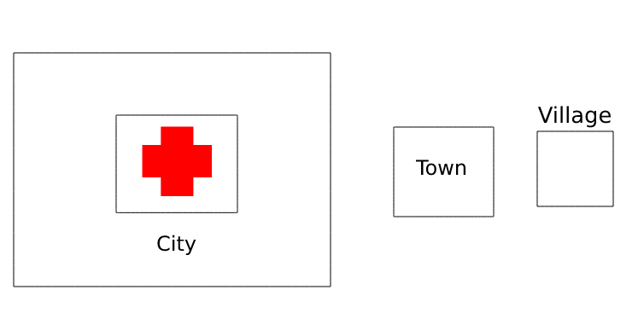

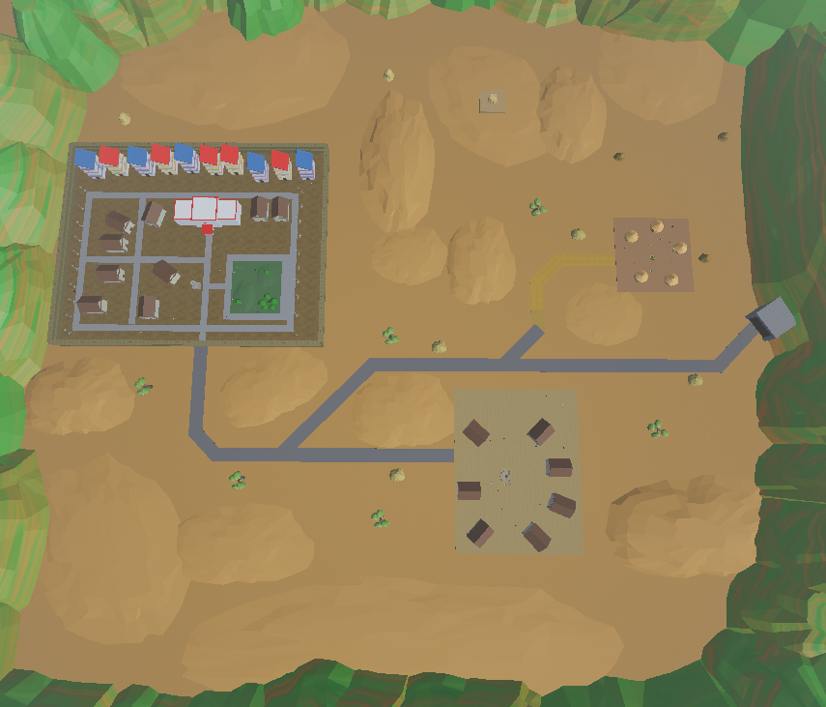

## Key World Features

* Large Map to explore
* Varied Terrain to drive over
* Different Locations to visit

## The Physical World

**Overview**

**Key Locations**

Main city

Small Town

Rural Village

Museum

Gallery

**Travel**

- Car: for longer distances

-Walking: for inside buildings, short distances.

**Scale**

Scale of buildings and objects is in proportion to standard Roblox characters.

Scale of map is shrunken from realistic proportions to reduce travel time

**Objects**

* Syringe
  + Very important, used to obtain blood samples from NPCs
* Medical kit
  + Very important, used to treat infected NPCs
* Blood samples
  + Important, can be tested to find infected NPCs
* Blood testing machine
  + Important, tests blood samples to find out which NPCs are infected
* Barricade
  + Important, used to block off the origin of the disease
* Medical Tents
  + Important, will be used to quarantine infected NPCs
* Car
  + Allows faster travel between locations

**Weather**

- No weather

**Day and Night**

- No Day/Night cycle

**Time**

There is a timer used to rank the players, and to determine the amount of coins they receive.

## Graphics

### Overview

Graphics designed to match and resemble standard Roblox graphics. Simplistic shapes and colors are used. Low level of texturing.

### 2D/3D Rendering

3D rendering used. Standard Roblox default settings

### Art Style

Typical ROBLOX style consisting of simplistic 3d models and textures.

### Animation

Animation done using Roblox game engines tools, such as the ‘tween’ system.

### Camera

For museum and game mode, players use Roblox standard camera: free rotate 3rd person and first person

Guided tour mode uses first person forced perspective(basically one long cutscene/video)

### Lighting Style

Lighting is mostly for visibility. No dynamic lighting was used.

## Other Technical Features

### Sound

Sound consists only of background music and standard Roblox default sound effects

### Physics

Standard ROBLOX Default physics

### Collision Detection

Standard ROBLOX default Collision Detection

### A.I.

No AI used at all. No need for automated movements in NPC’s or any RNG in the game. Everything is pre-scripted.

One NPC uses basic Roblox pathfinding AI, but it is still scripted and does not deviate between playthroughs. Pathfinding was simply easier to implement than manual coding of movement.

## Game Engine

### Overview / Requirements

Must Be Roblox Game Engine

### Engine Short-list

N/A

### Chosen Engine

Roblox game engine: (Stipulated by requirements. No alternatives allowed)

# The World Layout

## Overview

The World has one city, 2 towns and 4 villages where the city is in the middle of the map with the hospital in it and 2 towns beside the city and 2 villages beside each town.

Final Game: The world consists of 1 city, 1 town, 1 village, roads and 1 cave.

Museum consists of 4 rooms with a connecting atrium, all containing exhibits.

Tour consists of 5 areas arranged in a line containing exhibits.

## World Layout Details

The map is suppose to have a hospital in the city where the player spawn with a town between the city and the villages.

World Layout

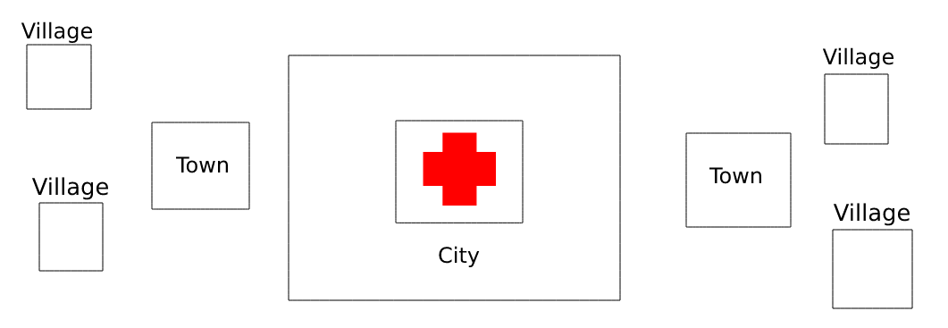Prototype

Final Design:





In-game Top Down View

# Game Characters

## Overview

N/A

## Creating a Character

Using Players Personal Roblox Avatar

## Hero/Heroes

A Doctor from Unnamed International health organization sent to investigate the emergence of a new disease(this is the player).

## Friends

Doctor NPC’s to explain helpful information

Tour Guide(Nurse Florence): NPC who provides information during the tour

## Enemies & Monsters

N/A

## Bystanders

Large collection of assorted ‘patients.’ No distinct personalities, just varied lines to prevent repetition. Functionally identical

# User Interface

## Overview

Most of the UI will be shown only when necessary such as when the player did the minigame wrong or when the story continues and when the player interacts with objects or UI buttons in the game. Most of the UI will be simple looking but also have some futuristic UI mix in the game.

## In-Game Control System

Standard Roblox controls, Shop menu, hold shift to sprint, click on UI pop ups to interact

## Front-end and Menus

Shop menu to select vehicles.

Standard Roblox toolbar and inventory.

# Weapons N/A

## Overview

None

## Weapon Details

None

# Vehicles

## Overview

2 categories of vehicles. Cars and city cars. City cars are just smaller cars. Both use the same control layout of forward, backward and steering. Vehicles differ only by aesthetics. Functionally identical in programming and controls, with differences in maximum speed and turning angles.

## Vehicle Details

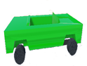 The Car

* The first car made to test if we could implement driving. The bottom section is simple and made of basic parts in Roblox by Perry, and the green shell of the car was provided by Yi Kai. This regular car had the best controls out of all the cars. The script component used in this car is later reused for all other cars in the game, with slight changes to variables such as top speed and steering angle.

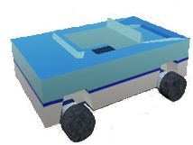 The City Car

* The first car made to be used in the city, it is actually a copy of the regular car, just scaled down so that it can be used within the city area, and because it is easier than to make a new car from scratch. However, because it is scaled down from the original, the physics of the car is more unstable
* Texture used is actually a reused arrow texture originally for the waypoints and UI, used on the car to make it look better as it was originally made on a whim and We did not want to spend more time on it than we needed to.

The Bumper Car

* Made to lean into the messy physics of the city car, the bumper car was an idea we had as an alternate version of the city car because it often collided into objects
* Has an invisible object above the back of the bumper car made to prevent the bumper car from flipping over onto it is back completely, its
* This was made as the client feedback at the time reflected very positively on the addition of vehicles to the game, thus this and more vehicles were added to create the shop feature

The Rapid Responder

* The original idea of the car came from an image of a vehicle resembling this one seen during initial research of the topic during ideation of the project. While adding more vehicles into the game, it was decided to create this as it was the original inspiration for the vehicle feature in the first place

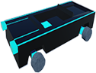

* This futuristic neon version of the car was made by Benjamin to add more variety to the city cars we had. It functions exactly the same as the regular car in terms of physics, it just uses a different texture.

The All-Hallowed Bumper

* This vehicle was created after an accident in which one of the ‘sick face’ textures was added onto the bumper car mesh. The grotesque appearance was memorable enough that when designing more vehicles to implement into the game, it was revived with a ‘halloween’ theme to create the All-Hallowed bumper.

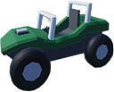The Dune Buggy

* Originally meant to be the ‘Final version’ of the original blockier car, when it was decided to instead add a shop feature for new cars rather than the original idea of simply having them available on the map, the Dune buggy was added as a separate vehicle.

The Car (Golden)

* Added as an homage to older games in which the shop would have a ‘golden’ option at an almost ridiculously expensive price that was marginally better than the ‘non-golden’ version. As the explanation stated previously, this is what the golden car is.

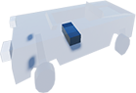The Car (Transparent)

* A suggestion made by Benjamin, it is the same as the regular car, but with Roblox’s transparency setting turned up slightly for each component of the car.

The City Car (Golden)

* Since we had a golden variant of the regular car, we decided it would be appropriate to have a golden variant of the city car as well. Unfortunately, the ‘enhanced’ stats of the (Golden) variants has only worsened the already poor handling of the vehicle. Its faster than the default though.

# Musical Scores and Sound Effects

## Overview

Basic background music. Default Roblox noises(footsteps, dying noises, etc)

## Sound Design

Uses Roblox standard sound system. Background music is 2d. Footsteps and other default Roblox sounds are in 3d.

## Musical Scores

Generic Background music found in Roblox default assets

Roblox Sound ID: 1846631912

## Sound Effects

Default Roblox sound effects.

# Single-Player Game

## Overview

Like stated before, there is no multiplayer included into the game.

## Key Features

Open world map to explore

Time based scoring system

Different obtainable cars to drive around the world

Learning about the Ebola virus

Large Gallery on the Ebolavirus

Guided tour and quiz on the Ebolavirus

## Story

The story is used in the main game section, and is based on the original events of the first major Ebola outbreak in Guinea.

The player is a doctor who has been called to a remote country due to the appearance of a mysterious new disease that has begun to afflict its people. The player spends the first act inside the city taking samples from sick people to test in order to find and identify the disease.

The player, after identifying the disease as the ebolavirus, leaves the city and travels to other areas of civilization to trace the source of the infection, providing medications to sick locals and quarantining other infected NPCs in the process, eventually, after questioning enough people and following the trail, they are told to go to a cave which the disease originated from, by a relative of the first victim and have it sealed.

After containing the source of the virus the player is now treating the remaining victims of the disease, who have been quarantined at their homes. The player is to go to each civilized area, and treat the people who were infected

## Hours of Game play

0.5 to 1 hour

## Victory Conditions

The player wins the game by containing the source of the virus and treating all the infected NPCs in the map. The game will then give the player’s completion time, and reset everything, thus ending the game, and allowing players to try and complete the game with a faster time. The player loses the game by letting all the NPCs get infected.

## Saving and Loading

Saving and loading is done manually by the player via a UI button.

The player’s data/progress through the game will be sent to Roblox server to be saved even if the player logs off the game. When the game is launch, the game will then retrieve the data when the player joins the game if the player has save before. If the player never click the save button, the server will not save the player’s game data, this excludes the car shop and the player’s coins, and will instead use old data of the player when the player join the game again if they have played the game before. Once the player finishes the game, the player’s game data will reset to start from the very beginning of the game while the player’s coins will increase depending on the results and will be save to the server so that the player can buy different cars from the car shop.

# Multi-Player Game

## Overview

N/A. There is no multiplayer features in the game. This game was intended for single player only.

## Max Players

1 Player. It has no intended multiplayer. Due to Roblox Built in multiplayer compatibility it is possible that multiple players could be in the same game at one time but this has no effect on the game itself nor the end score of the player.

## Server-Style

Standard Roblox server will create server for each player that join the game since only one player can join the game at a time.

## Internet

Due to how Roblox works, Internet is required to play the game. Uses Roblox Hosted Servers.

## Persistence

It is not very persistence as some part of the game only the player can see while some parts everyone can see and some of the objects in the game only happens once such as items or doors opening and will not be accessible to other players once one player does it which meant that some players will not be able to join the player that does it first.

## Saving and Loading

Nil

# Tools

## External Software to use

Blender used for 3d modelling.

Photopia and Photoshop used for image editing.

## World Editing

Uses Roblox default game editor.

## Character Creation

Characters created via importing default player models, importing various player models sampled from Roblox friend’s list via a plugin character importer, and re-arrangement and copying of various accessories onto default player models to create NPC characters.

## Internal Tools

Roblox store to get free assets from other creators to be used in the game.